


Test Summary Report
Version: 01.0
Updated: 17/04/2020
Author: IBM Global Services

Revision History
Revision Number | Date | Revision Author | Description
0.1 to 1.0 | 17/04/2020 | Sujit K Swain | Changes will be not tracked.

Distribution
Name | Title | Sign-off Required

Table of Contents
1. BackGround 4
2. Purpose 4
3. Intended Audience 5
4. Overview / Executive Summary 5
5. Test Case Design/Execution Goal: 6
6. System Environment/OATS Configuration 6
7. Application connectivity with tool 7
8. Test Design/execution Summary 9
9
9. Test Case Execution Results 9
10. Defect/Issue Summary 10
11. Analysis and Conclusion 10
12. Risk 10
Appendix A – Lesson Learnt 10

BackGround

This document makes understanding on testing between the various application of the project like EBS, Fusion, web etc. with OATS.
This design document describes:
- Test Scenario Preparation
- Development of automated test scripts using Open Script tool
- Uses of development environments for Test
- Approach to verifying and reporting test results

Purpose

This document is the Final Test Report for Maaden Project Solid.
The key goals of this report are to:
- Provide a summary of the test execution and results
- Evaluate the test outcome
- Give recommendations with regards to overall test approval

Intended Audience

The target audience of the document includes all parties interested in or involved in testing the Maaden account.
The following have been identified as the audience for this document.
- IT Test Team
- Project Managers
- Business Analysts
- Senior Leadership
- Developers
- Data Architects
- Systems Architects

Overview / Executive Summary

This Test Report of the Maaden Project Solid provides insight into actual testing achievements.
The flow of the System Testing was as follows:

Work-flow for System Test

Document Test Requirement

Test Plan

Execute Test Cases

Design Automation Script

Defect and Issue
Logging

View Reports

Workflow Notes:

- Test Requirements– Cycles started with requirement gathering. As per the SOW development of Automated Test scripts (up to 20 scripts/ month) as part of the Regression Testing using OATS Tool. So as manual testing resources are not present in the project, it will be the responsibility of the developer or the concern module lead to provide the scenario details every month before start of the script development.

- Test Plan - The test plan is nothing but need to identify the test scenarios which needs to be automated during design phase. There might be some scenarios which is provided by developer but in an actual, it is not candidate for automation, in this case we need to ignore such scenario from the list. We can consider those scenario which can be automation candidate.

- Design Automation Script – Design the automation script as per the scenario finalized in the previous step with respect to module.

- Test Execute- Execute the designed automated script and fix the issue if it will be observed. Make the script runnable in this phase.

- Defect and issue logging – If any issue and defect found during the execution, logging the defect in the tool.

- Report– After execution the test the report needs to be documented as per evidence and shared with the concern team.

Test Case Design/Execution Goal:

- As per SOW, up to 20 test cases we can do automate in in the testing cycle.
- Testing Cycle would be 18th to 17th of every month.

System Environment/OATS Configuration

OATS (Oracle Application Testing Suite) has installed on Jump Server2(172.17.11.39).
To access the OTA server,
- Login with Login to Jump Server 1 (10.2.2.150) using own ID
- Login to Jump Server 2 (172.16.6.60) using own id
- Login to Jump Server3 (172.17.11.39) with user id- OBIDevAdmin2
- Open with OpenScript tool using administrator option to generate the script.
To access the OTM (Oracle Test Management) login with below URL
- http://DC1-OATS-V-01.Maaden.com:8088/otm using “administrator” User Id

Application connectivity with tool

Open Script has the beautiful feature to connect different application modules like web, EBS, fusion, web Services etc. to do functional as well as non-functional(load) testing. It is the inbuild feature from the open script tool which can be provided by Oracle.
To select the proper application details from the module in the Open Script and start using it.
E.g. - if you want to use EBS application you need to select Oracle EBS/Form functional Test and provide your URL in the generated code so that the tool will invoke the application and you can do the operation on this application on it.
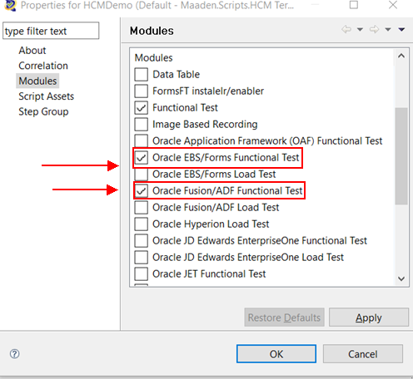

Test Design/execution Summary

Below scenarios are identified for the automation script design during Nov-Dec month period.

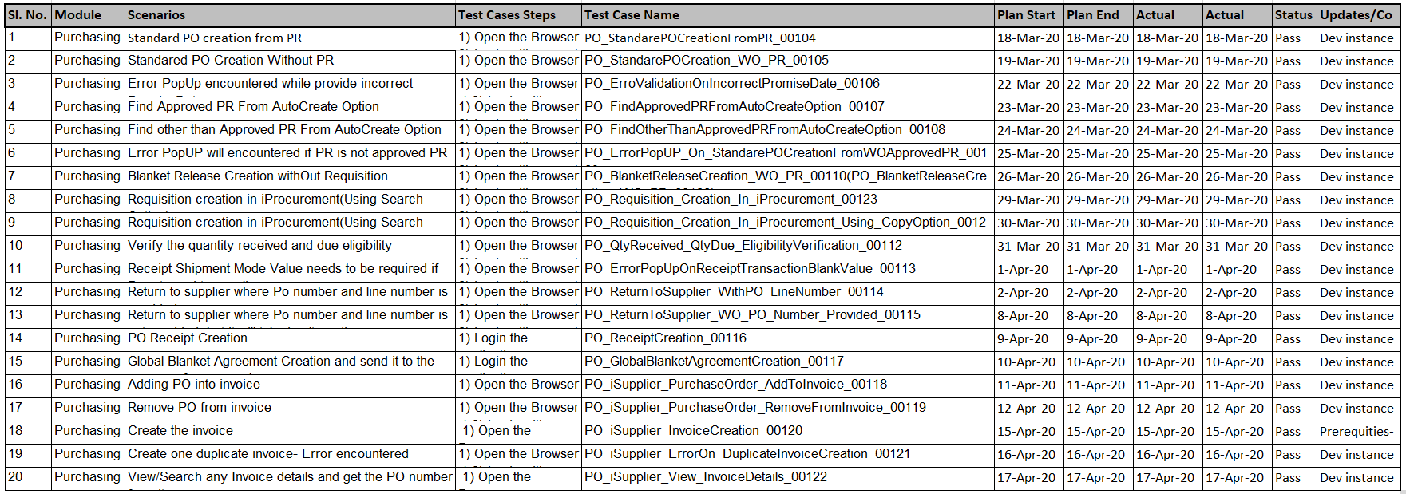

Excel View
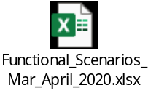

Test Case Execution Results

Above scenarios are executed and test artifacts has attached below.
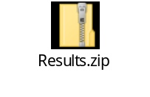

Defect/Issue Summary

When the actual regression pack will run and issue will be found if any, then this section will be filled up. As this moment, automation design phase is going on and however, no issue has been reported till now.

Analysis and Conclusion

During script generation, Dev and PClone instance is being used.
Dev Instance: http://riyoramgbm02.maaden.com:8050/
PClone Instance: http://riysoaclone.maaden.com:8010/

Majorly Dev instance is being used to generate the script due to less resources is using that instance where as PClone is widely used by developers, so frequently they are changing the user password, in-turn script might be failed.

Risk

- The OATS windows server is very much slow as it is in 3rd jump server.
  - Jump Server 1 (10.2.2.150)-> Jump Server 2 (172.16.6.60)-> Jump Server3 (172.17.11.39)
- Sometimes the application is taking long time to perform the operation in turn, might be the automation script execution got failed or it will take huge time to perform.
- The script might be failed if GL date has expired. Atleast we need to set the GL date open at every month.
- Script might be failed, if application is inconsistence.
- If any property will do modify by developer without prior intimation to tester, the script will be failed.
- If application got crash, then the script will be failed.

Appendix A – Lesson Learnt

What process/practice worked well and should be repeated for future testing efforts?
- Ensure the Test cases/scenarios are written/given by the dev team is based on the proper format which can be easily understandable.
- We need to ensure the test cases/ scenarios are not too big. This is making the traceability very difficult

